ITA0601 – MACHINE LEARNING
LAB EXPERIMENTS
EXP 7: Logistic Regression (LR) algorithm in python
Datasets:
Dataset 1: Student Placement Prediction
CGPA | Aptitude Score | Communication Score | Placement
9.2 | 90 | 88 | 1
8.8 | 85 | 84 | 1
8.5 | 82 | 80 | 1
7.2 | 72 | 70 | 0
6.8 | 68 | 65 | 0
9.0 | 91 | 89 | 1
7.0 | 70 | 68 | 0
8.7 | 86 | 83 | 1
6.5 | 65 | 60 | 0
9.1 | 92 | 90 | 1
Python Code:
from sklearn.linear_model import LogisticRegression
X = [
[9.2, 90, 88],
[8.8, 85, 84],
[8.5, 82, 80],
[7.2, 72, 70],
[6.8, 68, 65],
[9.0, 91, 89],
[7.0, 70, 68],
[8.7, 86, 83],
[6.5, 65, 60],
[9.1, 92, 90]
]
y = [1, 1, 1, 0, 0, 1, 0, 1, 0, 1]
model = LogisticRegression()
model.fit(X, y)
new_sample = [[8.9, 88, 85]]
prediction = model.predict(new_sample)
print("Predicted Class:", prediction[0])
if prediction[0] == 1:
print("Result: Placed")
else:
print("Result: Not Placed")
Output:
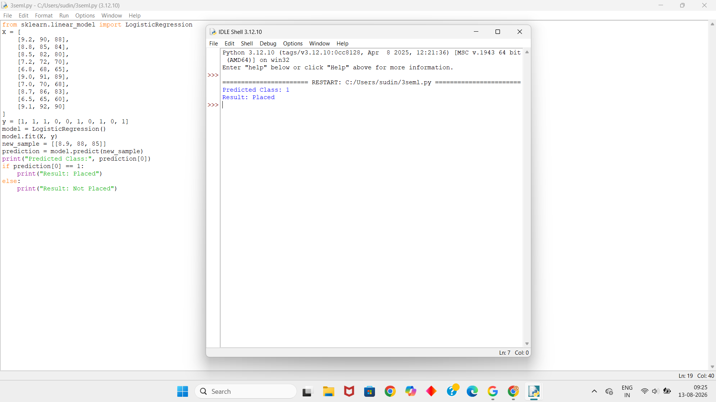
Dataset 2: Loan Approval Prediction
Income (₹ Lakhs) | Credit Score | Loan Amount (₹ Lakhs) | Loan Approved
8 | 780 | 5 | 1
7 | 760 | 4 | 1
6 | 730 | 5 | 1
4 | 620 | 8 | 0
3 | 590 | 9 | 0
9 | 810 | 4 | 1
5 | 650 | 7 | 0
8 | 770 | 5 | 1
4 | 610 | 8 | 0
7 | 750 | 6 | 1
Python Code:
from sklearn.linear_model import LogisticRegression
X = [
[8, 780, 5],
[7, 760, 4],
[6, 730, 5],
[4, 620, 8],
[3, 590, 9],
[9, 810, 4],
[5, 650, 7],
[8, 770, 5],
[4, 610, 8],
[7, 750, 6]
]
y = [1, 1, 1, 0, 0, 1, 0, 1, 0, 1]
model = LogisticRegression()
model.fit(X, y)
new_sample = [[7, 760, 5]]
prediction = model.predict(new_sample)
print("Predicted Class:", prediction[0])
if prediction[0] == 1:
print("Result: Loan Approved")
else:
print("Result: Loan Rejected")
Output:
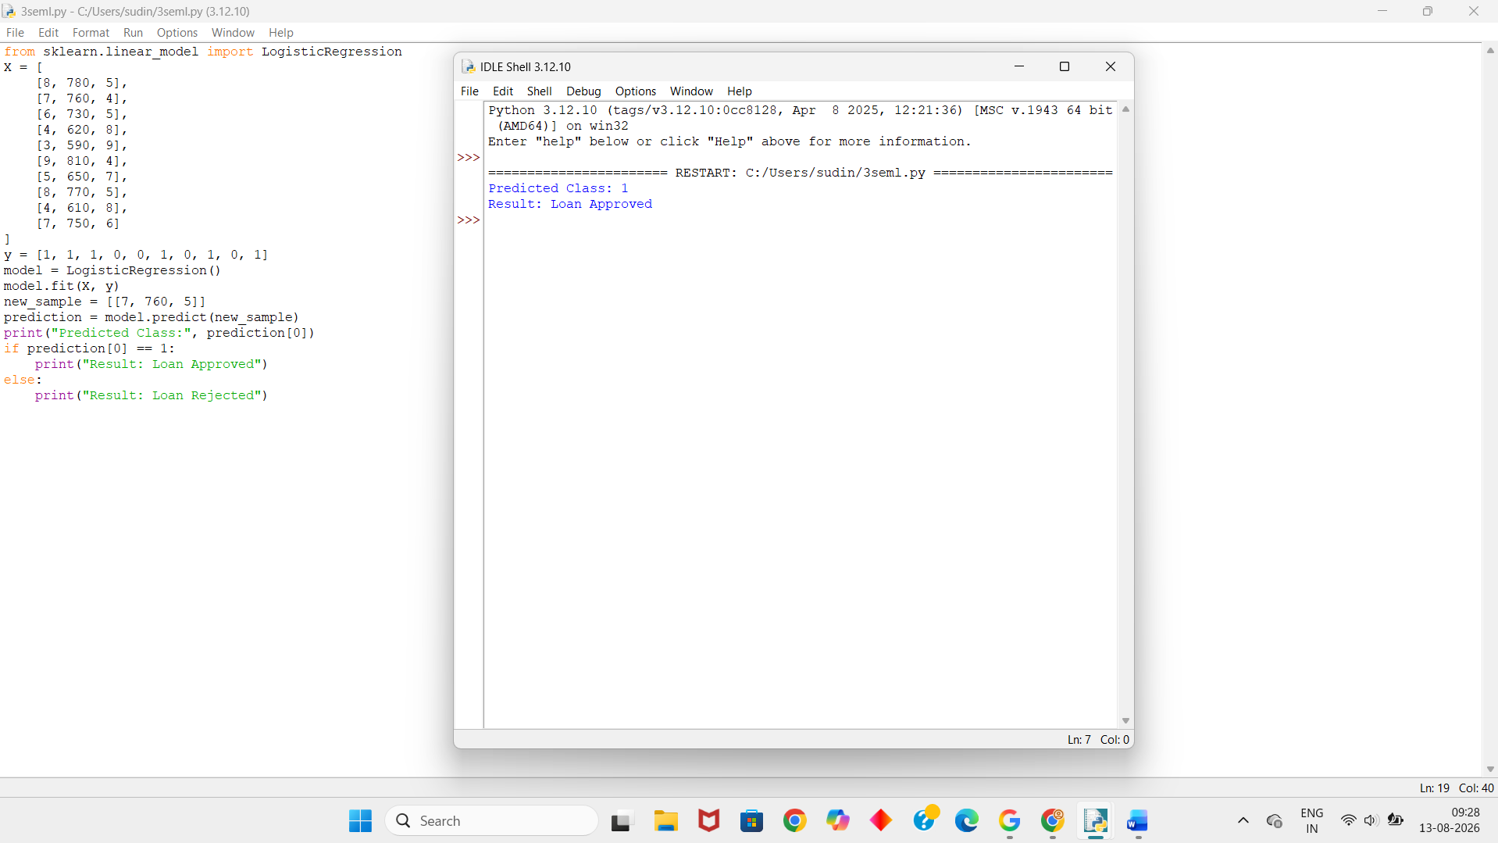
Dataset 3: Disease Diagnosis
Temperature (°C) | Heart Rate (bpm) | Oxygen Level (%) | Disease
39.1 | 112 | 94 | 1
38.8 | 109 | 95 | 1
37.0 | 78 | 99 | 0
39.3 | 115 | 93 | 1
36.8 | 74 | 98 | 0
38.7 | 110 | 94 | 1
37.1 | 80 | 98 | 0
39.0 | 113 | 92 | 1
36.9 | 76 | 99 | 0
38.9 | 111 | 93 | 1
Python Code:
from sklearn.linear_model import LogisticRegression
X = [
[39.1, 112, 94],
[38.8, 109, 95],
[37.0, 78, 99],
[39.3, 115, 93],
[36.8, 74, 98],
[38.7, 110, 94],
[37.1, 80, 98],
[39.0, 113, 92],
[36.9, 76, 99],
[38.9, 111, 93]
]
y = [1, 1, 0, 1, 0, 1, 0, 1, 0, 1]
model = LogisticRegression()
model.fit(X, y)
new_sample = [[38.8, 110, 94]]
prediction = model.predict(new_sample)
print("Predicted Class:", prediction[0])
if prediction[0] == 1:
print("Result: Disease Present")
else:
print("Result: Disease Absent")
Output:
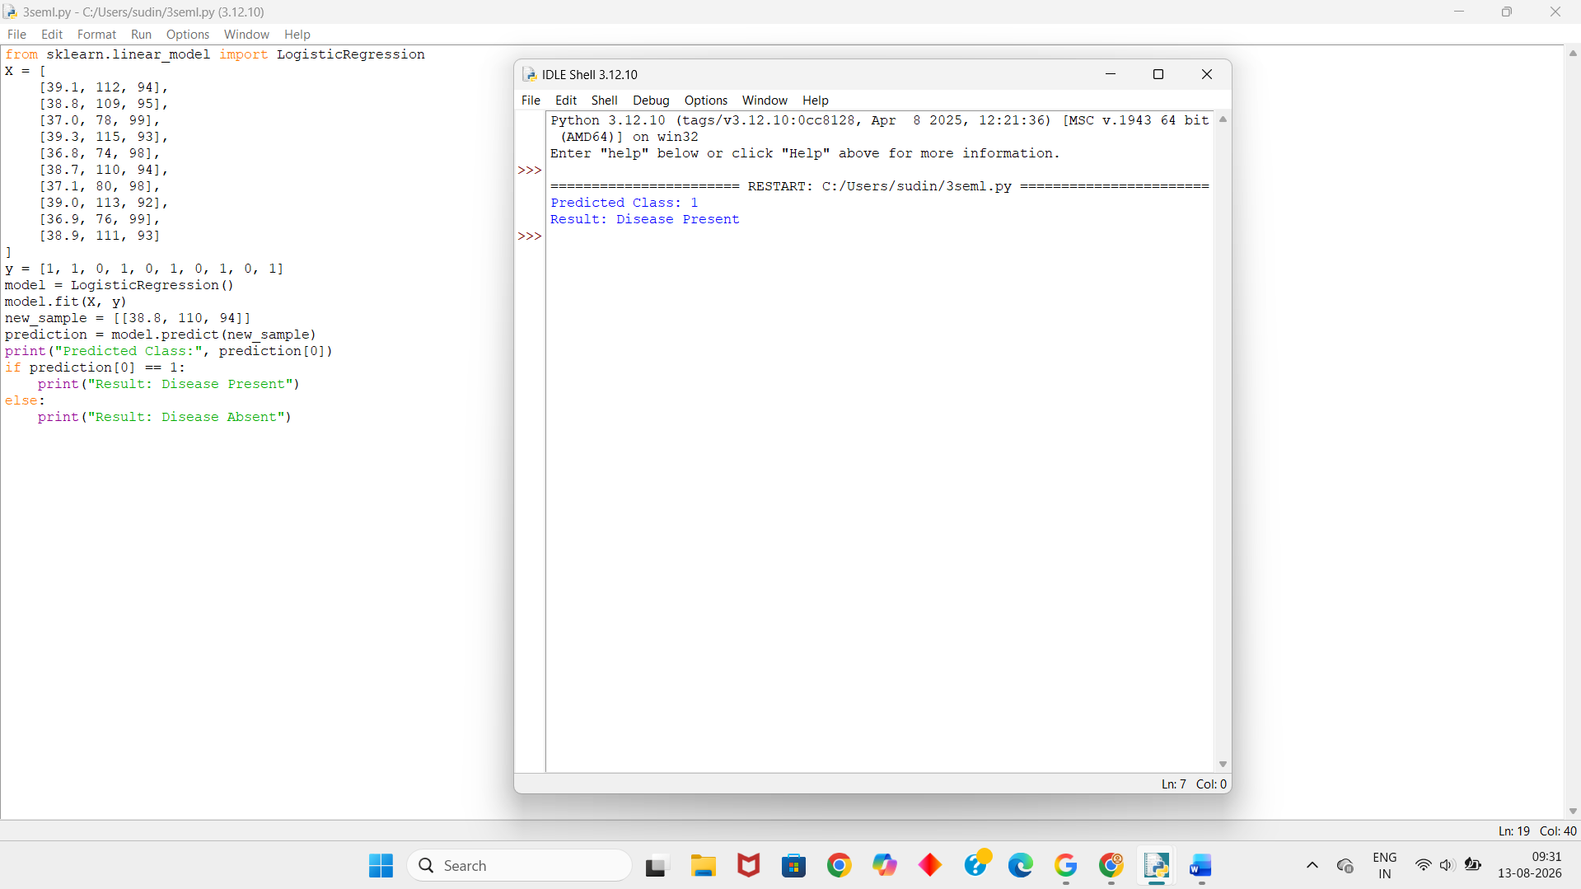
Dataset 4: Employee Promotion Prediction
Experience (Years) | Performance Score | Training Hours | Promotion
10 | 95 | 50 | 1
9 | 92 | 48 | 1
8 | 90 | 45 | 1
4 | 70 | 25 | 0
3 | 65 | 20 | 0
11 | 96 | 52 | 1
5 | 75 | 30 | 0
8 | 89 | 44 | 1
2 | 60 | 18 | 0
7 | 87 | 40 | 1
Python Code:
from sklearn.linear_model import LogisticRegression
X = [
[10, 95, 50],
[9, 92, 48],
[8, 90, 45],
[4, 70, 25],
[3, 65, 20],
[11, 96, 52],
[5, 75, 30],
[8, 89, 44],
[2, 60, 18],
[7, 87, 40]
]
y = [1, 1, 1, 0, 0, 1, 0, 1, 0, 1]
model = LogisticRegression()
model.fit(X, y)
new_sample = [[8, 91, 46]]
prediction = model.predict(new_sample)
print("Predicted Class:", prediction[0])
if prediction[0] == 1:
print("Result: Promoted")
else:
print("Result: Not Promoted")
Output:
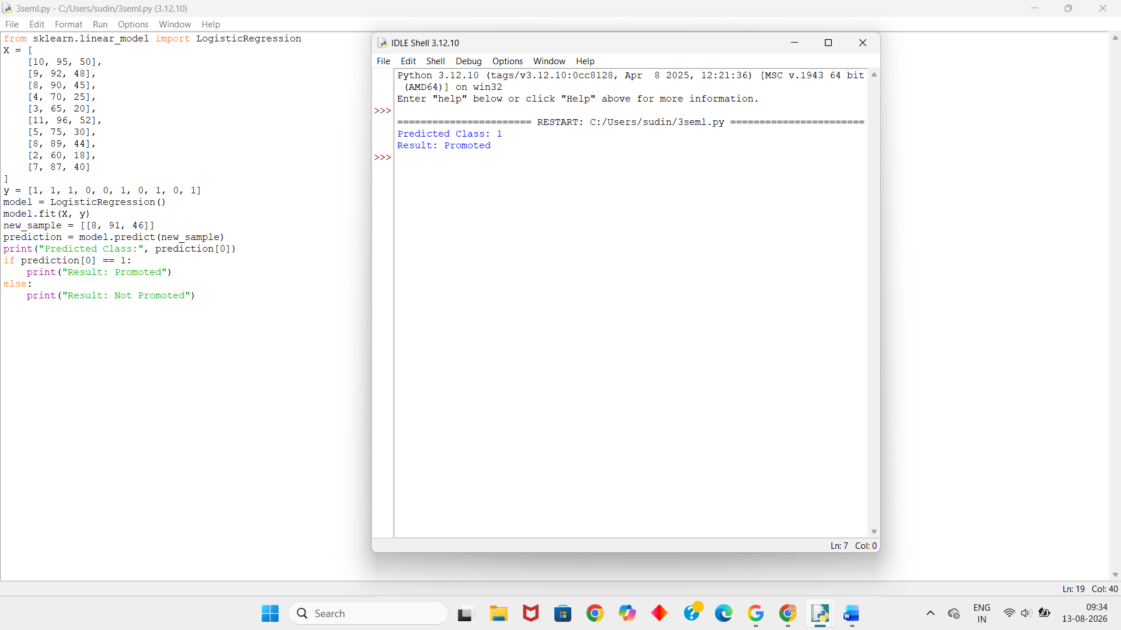
Dataset 5: Customer Purchase Prediction
Age | Annual Income (₹ Lakhs) | Spending Score | Purchase
22 | 3 | 30 | 0
25 | 4 | 35 | 0
28 | 5 | 45 | 0
32 | 7 | 60 | 1
35 | 8 | 65 | 1
40 | 9 | 75 | 1
45 | 10 | 80 | 1
30 | 6 | 55 | 1
24 | 4 | 40 | 0
38 | 9 | 70 | 1
Python Code:
from sklearn.linear_model import LogisticRegression
X = [
[22, 3, 30],
[25, 4, 35],
[28, 5, 45],
[32, 7, 60],
[35, 8, 65],
[40, 9, 75],
[45, 10, 80],
[30, 6, 55],
[24, 4, 40],
[38, 9, 70]
]
y = [0, 0, 0, 1, 1, 1, 1, 1, 0, 1]
model = LogisticRegression()
model.fit(X, y)
new_sample = [[34, 8, 68]]
prediction = model.predict(new_sample)
print("Predicted Class:", prediction[0])
if prediction[0] == 1:
print("Result: Purchased")
else:
print("Result: Not Purchased")
Output:
